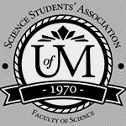
Science Student’s Association Meeting Attendance
September 27, 2021

Position | Name | Present

President | Chloe McElheron | No (regrets; proxy Guneet)
Vice President | Stuti Gupta | Yes
Chairperson | Yashas Samtani | No (regrets)
Secretary | Natalie Ngu | Yes
Senator | Kyra Cebula | Yes
Senator | Serena Philips | Yes
Senator | Dana Segal | Yes
UMSU Representative | Molly Crandal | Yes
UMSU Representative | Jasmine Tingey | No (regrets; proxy Natalie)
UMSU Representative | Tiffany Tantakoun | Yes
UMSU Representative | Tristan Rohatynsky | Yes
Accessibility Representative | N/A | N/A
Indigenous Students’ Representative | Zoe Quill | Yes
International Students’ Representative | Janvi Vaswanni | Yes
LGBTTQ* Representative | N/A | N/A
Women’s Representative | Julia Le | Yes
First Years’ Representative | Gabby David | Yes

Treasurer | Guneet Uppal | Yes
Director of Academics | Divleen Mangat | Yes
Director of Communications | Maria Manigque | Yes
Director of Special Events | Hajrah Ata | Yes
Director of Student Services | Annie Jiang | Yes
Executive Assistant | Fares Hossain | Yes
Academic Programmer | Brant Ditchfield | No (regrets)
Academic Programmer | Sebastian Chamorro | Yes
Communications Programmer | Paul Jerard Layug | Yes
Communications Programmer | Amy Lloyd | Yes
Lounge Programmer | Mashtura Khan | Yes
Special Events Programmer | Hannah Garber | Yes
Special Events Programmer | Sion Yi | Yes
Special Events Programmer | Tran Nguyen | Yes
Student Services Programmer | Devin Habon | Yes
Student Services Programmer | Kanso Alaka | Yes
Student Services Programmer | Tasnim Rahman | Yes

Science Student’s Association Meeting Minutes
September 27, 2021
Called to Order: 6:04 PM
- Acknowledgement to use of Treaty Land
Zoe Quill acknowledges that we are meeting on treaty land.

- Approval of Agenda
Stuti Gupta motions to approve the amended agenda Dana Segal seconds; Motion passed.

- Approval of Minutes
Stuti Gupta motions to approve the previous meeting minutes from the meeting held on (Sept 13, 2021), Dana Segal seconds; Motion passed.

- Council Reports
- President & (Vice) President
Pres/VP Report - September 24th, 2021

SEA Meeting
- Introductions by:
  - VP of Student Life - Savannah Szocs
  - Student Services Coordinator - Tom Tran (studentclubs@umsu.ca or ttran@umsu.ca or 204-480-1412)
- Club Exec Portal
  - Found on the umsu site > student clubs and associations > club portal for student clubs/departmental clubs
  - FAQ page is a great page and updated with general and unique questions
  - Club Resources:
    - Forms - renewal - roster update
    - Clubs directory page update
    - Community initiative funding
    - Forms for club operation funding
- Covid-19
  - Any campus event requires approval and apply a couple weeks in advance
  - They will send us more documentation regarding COVID/campus soon

SSA Donation Indian Residential School Survivors Society (IRSSS)
- Received a message from Raven Morrisseau - Indigenous Representative on ASBC
- September 30th is National Day of Truth and Reconciliation (formerly known as Orange Shirt Day)
- On this day, ASBC will be making a donation of $150 to the Indian Residential School Survivors Society (IRSSS)
- Looking to see if any councils would match their donation on this day or donate any amount available
- A way to support survivors of residential and day schools and show your support to the Indigenous community

Nimbus
- Signed our contract for a one-year license with Nimbus tutoring after many months of work between the past and present Academics teams to establish this partnership and program for Science Students!
- $2500 - one-year license covers:
  - Available to all science students
  - Free tutoring programs for students set up with SSA and CSSA
  - Mentorship program with WICS
  - Access to the Nimbus tutoring app and platform to match tutors with tutees based on availabilities and courses
  - Match mentors with mentees in the mentorship program
  - Access to promotional materials and planning provided by Nimbus
  - Used among many councils/associations on campus (UMSU, UMES, CSA, ASBC) with very high success
- This year will be our pilot year, we will collect feedback from the Academics Team and students, and usage data from Nimbus, to leave for next year’s council with our recommendation as to whether this is a beneficial service to continue renewing our annual license for

Council Calendar
- Set up through Outlook Calendar - everyone has the ability to view and access
- Added so far: meetings, workshops, important dates, office hours
- I have categorized everything so it is colour coded/easier to read
- Feel free to add new categories as you add in your events and reminders

Science Leadership Scholarships
- We did not receive a large amount of applicants in May
- The application has been reopened and extended - info and application portal on SSA website
- Deadline: September 30th @ 11:59pm

Document of Summarized Expectations/Procedures
- Stuti and I are working on putting together a concise document that outlines common councillor expectations/procedures that we can pin in the discord chat for easy reference
- Stay tuned, we will have this up soon!

By-Elections
- We have started discussing a By-Election to occur soon to fill the vacant elected positions of Accessibility and LGTBQA* Representatives on our council.
- We are in the process of finding a CRO (non science student to hold the elections) - will put out an ad if needed.
- Depending on the availability of the CRO, we hope to hold them in October.
- Heads up to comms - we will advertise the positions and dates once finalized
- Forms and election procedures will be discussed at the next Executive meeting and all documents will be sent to the SSA main email.

Motion:
Motion to approve $150 for a matched donation to Indian Residential School Survivors Society (IRSSS) on National Day of Truth and Reconciliation

Molly said we wanted to change our LGBTQA name to include the proper name.
Stuti said we can do more research and have an open discussion about this next meeting.
- Senate
- Nothing to report
- UMSU
Date: September 23rd, 2021 Time: 6:30 PM - 7:27 PM

Tristan Rohatynsky, Jasmine Tingey, Molly Crandall & Tiffany Tantakoun Reports:

General Notes:
- Presentation from CFS about services they provide
- Governance is holding off on presenting the BOD reform motion as they have received many concerns and would like to get through these

Current Business:
Motions:
Motion 0521: Unified Statement of Solidarity
- UMSU rededicate itself to condemning all acts of racism, discrimination, bigotry and violence against the Israeli, Jewish, Muslim, Palestinian, and other affected communities
- that UMSU release a statement showing their solidarity and support towards all students, staff and faculty at the University of Manitoba impacted by recent events in the Middle-East. In addition to reiterating the safe spaces, mental health, and spiritual supports on campus for all Jewish, Israeli, Muslim, Palestinian, and other affected community.
- Motion: brought to the exec team for review; individual councils should review as well as the exec is asked to regard the student body at large

Reports from the Executives:
President’s Report (Brendan Scott):
- CRSC Mandatory Vaccination Policy will follow the government's lead when it comes to unvaccinated individuals on campus.
- The portal is open to upload immunization status
- Unvaccinated students must undergo testing every 48 hours otherwise
- Nov 14th → you have to pay for your own tests to come to campus
- MAPSS
- Voted U of W in.
- Now represent 71,000 students
- UMSU Annual Member Survey out now, please complete. Imperative to our advocacy efforts.
- UPASS
- Filling out details now

VP Advocacy’s Report (Emily Kalo):
Make sure we all have access to a comprehensive list of resources in light of the recent events happening to many universities across the world

- Sexual Violence Resources
- If you or someone else is in immediate danger, call 911 and/or campus security at 204-474-9341.
- To get coordinated support and information to on campus and community resources, contact the UM Sexual Violence Resource Centre at 204-474-6562 or emailsvrc@umanitoba.ca.
Counselling:
- Student Counselling Centre provides both crisis support and trauma counselling to students and is free and confidential.
Safety and support planning:
- Student Support Case Management helps in creating safety plans for on and off campus as well as support plans that are tailored to individual needs and consultation services for handling concerning situations.
- Security Services at the University of Manitoba provides ongoing safety planning on campus (e.g., Safe Walk) as well as acts as a liaison with both internal and external agencies (e.g., Winnipeg Police Service).
Academic accommodations:
- Both the Vice President Advocacy and Student Advocacy, offer confidential support to assist academic requests (e.g., deferrals, withdrawals, complaints, etc.)
Other safe spaces and supports:
- Health and Wellness Office provides information on consent and sexual violence. Free information and consultation related to health, wellness and sexual violence resources (both on and off campus) along with how to access them, are available.
- Indigenous Student Centre provides support and assistance in a manner consistent with the culture and values of Indigenous Peoples, including personal counselling.
- International Centre provides support for all university students including international students and internationally minded students.
- Office of Human Rights and Conflict Management: Any person who believes that any member of the University of Manitoba has been subjected to sexual violence in the course of university related employment, study, training or activities may discuss their concerns or make a complaint.
- Residence Life Office provides service to all students currently living in residence.
- For immediate 24/7 sexual violence support, call the Klinic Sexual Assault Crisis Line at 1-888-292-7565.

VP Community Engagement (Tino Dogo):
- Leisure Guide
- With sessions running from early November to later in December, we’re now accepting proposals for classes interested facilitators would like to teach.
- The deadline for these proposals is Oct 1st
- Financial Webinars
- Throughout the Fall and Winter terms, we’re hosting financial wellness webinars that will be facilitated by financial professionals from CIBC.
- Teach students about money management by focusing on credit management, saving, and investing.
- We’re really targeting the “but they didn’t teach this in school” meme.
- There will be a total of 6 sessions run in the evening to accommodate student schedules.
- Sustainability
- Very happy to report that a draft copy of the UM Climate Action Plan has been made available to the UM Sustainability Committee for review and preliminary feedback before a finalised copy is presented.

VP Finance and Operations (Brooke Rivard):
- Climate Action Plan
- The most recent file to come out is the Universities Climate Action Plan. Once all these files have been read through, UMSU will have a better footing in where the University can improve, and how UMSU can play a role in ensuring a more sustainable campus.
- UPASS
- Not be offered for the fall term and as such students will not be assessed the fee.
- In place of this, students that provide proof of in person classes, have purchased a post-secondary bus pass, and are in financial need can receive a transit subsidy as was offered last year.
- We have met with Winnipeg Transit to discuss the terms of the UPASS agreement for the winter term going forward. Initial discussions have been fruitful, with the City being open to moving the end date of the agreement from the end of a fall term to the end of a winter term, ensuring that the program will have continuity for its fourth and final year for the agreement.
- Board of Trustees Focus Group
- Looking to fill 8-12 student positions for a term long focus group in order to assist in the strategic planning of the Union.
- This is an excellent opportunity for students who want to have their voice heard on UMSU’s finances and how its internal structures are set up for the future.
- You or anyone you know can apply for this until tomorrow, please send me an email if interested.
- Degrees continues to expand its menu and offer daily specials, so keep your eyes out for those.
- Also keep your eyes out for a promotion coming to Degrees in which you can win an UMSU gift card!

VP Student Life (Savannah Szocs):
- Member Services Committee
- Just a reminder to bring back to any clubs associated with your student associations: Please remind everyone to apply for student clubs funding ahead of the actual hosting of the planned event so that we can better guarantee reimbursement for the event.
- Financial Aid and Awareness UMSU’s
- Launched earlier this week and we are hoping to reach lots of students with some helpful information regarding student financial supports and resources on and around campus. Be sure to tune in if you’re interested, and please spread the word!
- Hardship fund
- Requesting money over 2K; reiterate that it's a small fund; not like financial aid and awards
- can’t be used to pay for tuition, more for payment for rent, groceries, childcare, bills, etc.
- Not meant to support students over the course of 6 months → one time thing

- Communications
- https://drive.google.com/file/d/1xfUWYgzr0M9SiY1FB5ZoBaFj65mT-UT-/view?usp=sharing

- Councillor Reports
- Special Events
- Nothing to report
- Academics
- Nothing to report
- Lounge Programming
For the question of the week giveaway, first week's winner was chosen:
Katherine Bazin
10$ starbucks giftcard was sent through the SSA email. All screenshots and info is also sent to SSA email. Recipient confirmed receiving giftcard.
For the question of the week giveaway, second week's winner was chosen:
Ash Kropp
10$ giftcard receipt was sent to the SSA email. All screenshots and info is also sent to SSA email. Recipient confirmed receiving giftcard.
Stuti asked how are office hours going.
Mashtura said we haven’t had any tickets or questions.
Stuti said if it is your office hours, try to get more engaged and increase engagement on our discord.
- Accessibility
- Nothing to report
- LGBTTQ*
- Nothing to report
- Women’s
- Nothing to report
- Indigenous
- Nothing to report
- International
- Nothing to report
- First Year’s
-Event went great! Thank you to everyone who joined in.
-Winner has already received their prize
- Student Services
SSA Student Services Report - September 27th, 6pm
Annie, Devin, Tasnim, Kanso
Email ssastudentservices@gmail.com

- Welcome to Fall Term Giveaway with Special Events
  - Gave away $200 worth of gift cards

- Upcoming - scheduling locker content retrieval dates

- Treasurer
Treasurer Report - September 27, 2021
The following E-transfers (+$1 each) were made:

To | Date of transfer | Amount ($) | For
Annie Jiang | Sep 16, 2021 | 25 | Starbucks GC
Mashtura Khan | Sep 21, 2021 | 20 | Giveaway
Gabrielle David | Sep 21, 2021 | 98.32 | Giveaway
Tasnim Rahman | Sep 23, 2021 | 25 | Starbucks GC
Kanso Alaka | Sep 23, 2021 | 25 | Starbucks GC
Devin Habon | Sep 23, 2021 | 25 | Starbucks GC
Divleen Mangat | Sep 25, 2021 | 80 | LabTrek gratuities  ($20/PI and $15/student)
Guneet Uppal | Sep 25, 2021 | 80 | LabTrek gratuities  ($20/PI and $15/student)

- Committee Reports
- Executive
Exec Report - September 20th, 2021

Funding Request - HSGSA
- We met with Toby from HSGSA regarding the funding request for the "Multidisciplinary Health Research Experience" (MHRe) program presented last meeting:
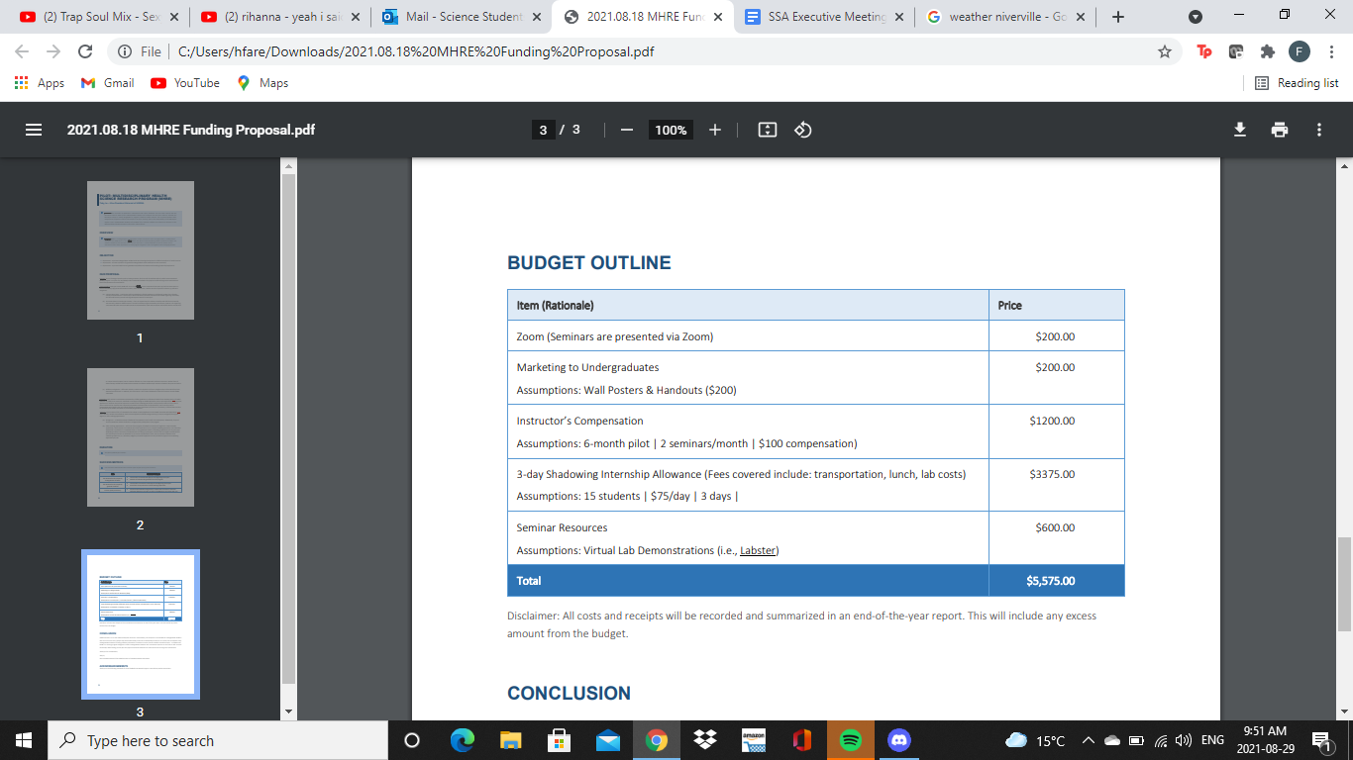
- He provided an amended copy that greatly reduced the prices, was presented as follows:
  - High priority to be funded: Instructors Compensation $1200.00
  - Medium priority: Seminar Resources $600.00
  - Total = $1800.00
- We also discussed that the $600.00 was a maximum amount they expected to have to spend, and that with the virtual platform, this number would likely be reduced
- We believe that these costs are crucial to the ability for the program to be run in its pilot year, HSGSA is now also covering a large portion of the cost
  - If the pilot program is successful, HSGSA will be able to apply for additional funding from other sources in future years

EXEC RECOMMENDS: Approval of up to $1800.00 for HSGSA for the "Multidisciplinary Health Research Experience" (MHRE) program.
- Receipts/documents will be submitted and they will be compensated up to that amount

Motions

Moved by Executive Committee:

WHEREAS SSA councillors are required to attend 75% of all scheduled full-council meetings;
WHEREAS a councillor has mandatory training for their job on Monday’s at 6pm until November 17th, 2021;
BE IT RESOLVED that Jasmine Tingey is excused from mandatory council meetings until November 17th, 2021.

- By-Laws
- Nothing to report

- Other Business
- Important Dates/Notes
Stuti Gupta motions to allow one of the councilors to chair.
Motion passed
Stuti Gupta motions to transfer chairing to Tasnim Rahman.
Motion passed.
Tiffany asked if we are going to have an SSA corn maze get together.
Tasnim said we could do a Doodle poll to vote.
Stuti asked if there was a group option for pricing.
Tiffany said she can call and ask.
Molly said her birthday is on October 19th, so we can go then.
Stuti said to put everyone’s birthdays in the calendar.
Tiffany asked if we are using SSA funds, do we have to motion for it.
Stuti said if Guneet is there, she can buy it and motion for to be reimbursed.
Natalie said to let her know if there are any mistakes in the past meetings’ attendance in regard to absences and regrets so we can fix the minutes in the next meeting.
Tiffany said there’s a tab for group booking for the corn maze.

- Dismissal
Guneet Uppal motions for dismissal at 6:54 PM, Molly Crandall seconds; Motion passed.

Motions
September 27, 2021
Motion Regarding: Donations | Category: Funding
Motion: to approve $150 for a matched donation to Indian Residential School Survivors Society (IRSSS) on National Day of Truth and Reconciliation
Status: Passed

Moved By: Stuti Gupta
Seconded By: Tristan Rohatynsky

Motion Regarding: MHRE Program Funding | Category: Funding
Motion: for the Approval of up to $1800.00 for HSGSA for the "Multidisciplinary Health Research Experience" (MHRE) program
Status: Passed

Moved By: Executive committee
Seconded By: Molly Crandall

Motion Regarding: SSA Meetings | Category: By-laws
Motion: WHEREAS SSA councillors are required to attend 75% of all scheduled full-council meetings;
WHEREAS a councillor has mandatory training for their job on Monday’s at 6pm until November 17th, 2021;
BE IT RESOLVED that Jasmine Tingey is excused from mandatory council meetings until November 17th, 2021.

Status: Passed

Moved By: Executive committee
Seconded By: N/A

